EEOP 6310

Optical Communication System

Report

Optical communication System Design from Dallas to New York

By

Vasudevan Sridharan (2021186455)

Madhusudan Pranav Venugopal (2021163441)

Nirmala Dasari(2021166928)

Archit Garg (2021178730)

Table of Content

|  |  |  |
| --- | --- | --- |
| **S. No** | **Topic** | **Page No.** |
| 1 | Aim |  |
| 2 | Design Parameters |  |
| 3 | Components |  |
| 3.1 | Transmission LASER Array |  |
| 3.2 | WDM MUX |  |
| 3.3 | Amplifier |  |
| 3.4 | Power control |  |
| 3.5 | Loop |  |
| 3.6 | Non Linear Dispersion Shifted Fiber |  |
| 3.7 | Power Equalizer |  |
| 3.8 | Optical Filter |  |
| 3.9 | Direct Receiver |  |
| 3.10 | Optical & Electrical Analyzer |  |
| 4 | Simulation Result |  |
| 5 | Conclusion |  |
| 6 | References |  |

|  |  |  |
| --- | --- | --- |
| **S.No** |  | **Page No** |
| **1** | **Aim** | **4** |
| **2** | **Description** | **4** |
| **3** | **Components** | **5** |
|  | **TxLaser Array** | **6** |
|  | **WDM MUX** | **7** |
|  | **Amp sys opt** | **8** |
|  | **Power Controlled** | **8** |
|  | **Loop** | **10** |
|  | **NLS** | **11** |
|  | **Power Equalizer opt** | **12** |
|  | **Optical Filter** | **13** |
|  | **Direct Receiver** | **14** |
|  | **Optical and Electrical Analyzer** | **15** |
| **4** | **Simulation Result** | **18** |
| **5** | **Conclusion** | **19** |
| **6** | **References** | **19** |

**Table of Figures**

|  |  |  |
| --- | --- | --- |
| **S.No** |  | **Page No** |
| **1** | **System Architecture** | **5** |
| **2** | **Tx Laser Array** | **5** |
| **3** | **Example of a schematic Using the Module Laser Array Transmitter** | **6** |
| **4** | **Transmitter** | **7** |
| **5** | **WDM MUX** | **7** |
| **6** | **Signal Processing in WDM\_MUX\_1\_Ideal** | **8** |
| **7** | **Amp sys opt** | **8** |
| **8** | **System Level Amplifier in the “power controlled” mode** | **8** |
| **9** | **System level amplifier in the “gain controlled” mode** | **9** |
| **10** | **Transfer characteristic of the amplifier** | **9** |
| **11** | **Loop** | **10** |
| **12** | **Realization of a ring using the loop module** | **11** |
| **13** | **Non linear Dispersive Fiber** | **11** |
| **14** | **Power Equalizer opt** | **12** |
| **15** | **Operation Power Equalizer Opt** | **13** |
| **16** | **Transfer function and Impulse responses** | **14** |
| **17** | **Direct Receiver** | **14** |
| **18** | **Schematics for Rx ook Module** | **15** |
| **19** | **Optical and Electrical Signal Analyzer** | **15** |
| **20** | **Simulation Result** | **16** |
| **21** | **References** | **19** |

1. **Aim:**

To simulate a dense WDM Optical Fiber Communication system from Dallas,TX to New York City, NY which meets the following specifications

Distance: 3000 km

Number of wavelengths: 40 follow ITU grid

Data rate per wavelength: 10 Gbps

Channel spacing : 10GHz

Bit Error Rate :10e(-15)

Total data rate: 400 Gbps.

1. **Description**

Optical communication is [communication](http://en.wikipedia.org/wiki/Communication) at a distance using [light](http://en.wikipedia.org/wiki/Light) to carry information. It can be performed visually or by using [electronic devices](http://en.wikipedia.org/wiki/Electronics). We chose a laser transmitter array capable of transmitting 40 different wavelengths (20 odd + 20 even channels/Frequencies) with the help of a bus. The emission frequency is chosen is taken as 192.5 THz and the channel spacing was taken to be 100 GHz. These are modulated externally. A Wavelength Division Multiplexer (WDM) is used to multiplex all these channels to form a single output channel. This single output signal is then passed through an ideal amplifier to amplify the signal power. This is then passed through an optical fiber of length 300 km. This whole distance is simulated by using a loop of length 60 km and running it for 5 times. Now, at the receiver, the signal is received. The very first component at receiver end is the amplifier which amplifies the signal as the received signal is of very low amplitude due to fiber losses. The fiber dispersion is compensated using dispersion compensators. All the signals are demodulated at the receiver by passing through a band pass filter and then through PIN diode. Channel analyzer and Signal analyzer are used to observe the output signals.

**System Architecture**

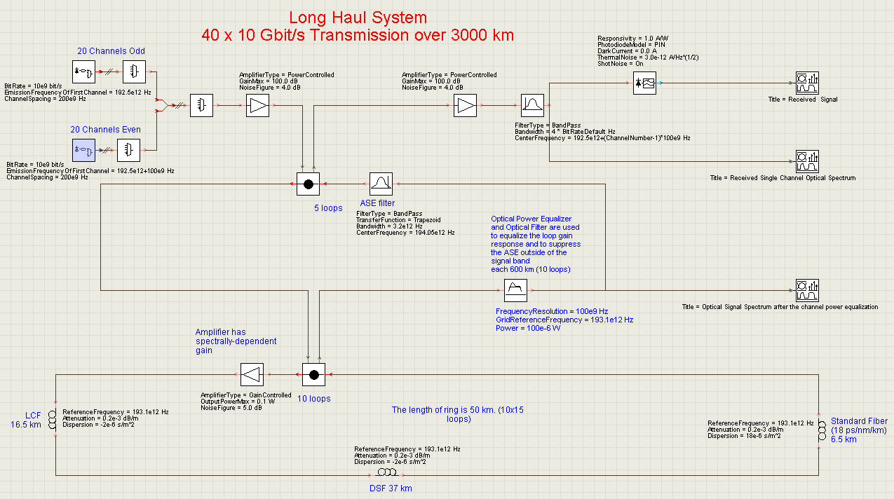

Figure:1

## Components:

## TxLaserArray

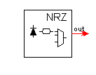  
Figure:2

To form a laser array, a single Externally Modulated Laser Transmitter module is used together with a SrcGr module (see [Figure 1](mk:@MSITStore:C:\Program%20Files\VPI\VPItransmissionMaker%208.7\doc\modules.chm::/TxLaserArray.html#1696296)). The latter module has been taken from Signal Processing’s HOF (Higher Order Function) Domain (see User’s Manual HOF Domain for details) and its task is to replicate a connected module multiple times while varying certain parameters. The absolute lasing frequency of the first channel is determined by EmissionFrequencyOfFirstChannel to define the absolute lasing frequency of the first channel. The frequency offset of each of the neighbored channels is given by ChannelSpacing. In addition to the frequency variation, the seed value responsible for the initialization of the bit generator and the laser, respectively, is changed via PRBS\_RandomNumberSeed. The number of WDM channels at the output is defined by specifying the bus width. Therefore, this module’s output must be connected with the subsequent one using Signal Processing’s Bus module (to be found in the Wiring Tools folder). The bus width is then defined by the parameter Bus Width in the Bus module’s setup. [Figure 2](mk:@MSITStore:C:\Program%20Files\VPI\VPItransmissionMaker%208.7\doc\modules.chm::/TxLaserArray.html#1696308) shows an example of how to use the Laser Array Transmitter in connection with a network design.

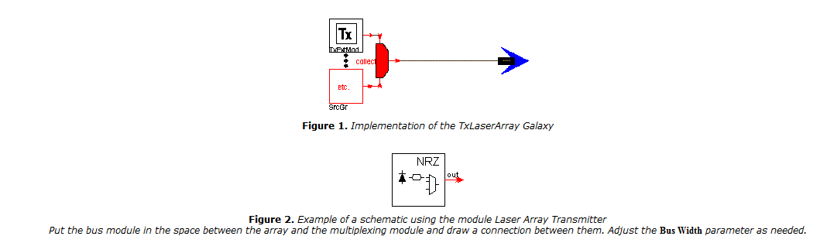

Figure 3.Example of a schematic using the module Laser Array Transmitter

Put the bus module in the space between the array and the multiplexing module and draw a connection between them. Adjust the Bus Width parameter as needed.

Since the SrcGr star included in the Laser Array Transmitter module simply replicates the Laser Array Transmitter and the stars inside of it, the parameters of these modules have been added to the parameter set of Laser Array Transmitter in order to be set individually. The target star of a parameter is labeled by a flag in the beginning of the parameter name in ambiguous cases.

For detailed explanation of the parameters, see the documentation on the modules Laser CW, Modulator Mach-Zehnder, Rise Time Adjustment, NRZ Coder, and PRBS Generator.

Logical Information

The logical information set which is attached to the output signals contains information on the transmitted bit sequence and the original pulse shape. A prefix to the label of this information set can be set by parameter ChannelPrefix. The full label of a channel will then be <ChannelPrefix>Channel<number of channel>, e.g., if ChannelPrefix is set Array1 and the module is connected to a bus of width 3, the information channels will be labeled “Array1Channel1”, “Array1Channel2” and “Array1Channel3”. If the ChannelPrefix is set to Automatic (the default), a unique prefix of the form “Array*xxxxx*” will be used, where “*xxxxx*” represents a randomly-generated integer between 0 and 99999.

If the logical channel information is not used by any other modules in the setup (such as clock recovery modules or BER estimators) it is possible to leave the ChannelPrefix set to its default value of Automatic. If, on the other hand, the logical channel information is required by other modules, it is best to set the ChannelPrefix to a known value. To use the information of a specific transmitter for the estimation of the bit error rate, set the parameter ChannelLabel of the BER estimator to the same value as the label of the respective information channel. A useful technique is to create a global parameter to hold the prefix, to ensure consistency of naming between the transmitter and other modules.

The labels of all information channels in a setup must be different, so it is not possible to run two laser arrays with identical settings of parameter ChannelPrefix (other than Automatic). An error message will be issued in this case.

Note: The parameter ChannelPrefix must not be empty, otherwise an error message will appear.

The Tx part has the following

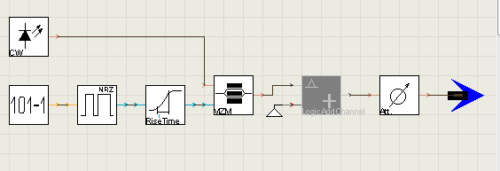

Figure 4:

**WDM MUX**

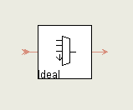

Figure 5:

In this module, incoming channels are merged to a single channel as shown in [Figure 1](mk:@MSITStore:C:\\Program%20Files\\VPI\\VPItransmissionMaker%208.7\\doc\\modules.chm::/WDM_MUX_N_1_Ideal.html" \l "1680944" \o "WDM_MUX_N_1_Ideal).

The parameter InsertionLoss defines the additional attenuation between the inputs and the output. The N input signals are added into the output signal. This process includes the joining of overlapping sampled bands (see VPItransmissionMaker™Optical Systems User’s Manual, Advanced Signal Representations, Multiple Frequency Bands, Joining Bands). The new sampled band will also have 2n samples. If the new band overlaps with another sampled band the joining process will be continued.

For a wavelength-independent coupler the minimum loss will be 10 log10(N) dB. For a wavelength-dependent multiplexer the minimum loss will be zero dB.

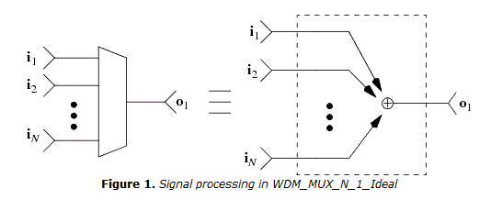

Figure 6:

# AmpSysOpt

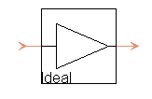

Figure 7:

## PowerControlled

|  |
| --- |
| In PowerControlled mode the pump power is variable and the parameter **OutputPower** specifies the total output power that is conrolled by enhanced parameters **SampledSignals**, **ParametrizedSignals**, **NoiseBins**, **Distortions**. |

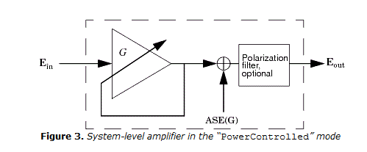

Figure 8:

At low input powers, the amplifier’s gain will be limited and the output power (averaged over one Block) will be limited, as in a real device, by setting a maximum amplifier gain Gmax by the parameter **GainMax**. This limiting is achieved by downscaling output power, P(f): P(f) =Pout(f)/k, where k is the ratio of the GainMax to the unscaled gain, where the unscaled gain value is averaged over the signal wavelength range by relating the total input and the total output powers. This power limiting is useful in providing realistic simulations. If the output power is set to an unrealistically high value, the output will always equal the power limited by the maximum gain.

## Gain Controlled

|  |  |
| --- | --- |
|  | In GainControlled mode (see [Figure 1](mk:@MSITStore:C:\Program%20Files\VPI\VPItransmissionMaker%208.7\doc\modules.chm::/AmpSysOpt.html#1742107)) the pump power is variable and the parameter GainShapeDescription allows you to specify the input signal amplification via parameters or gain profile. |

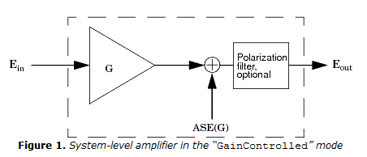

Figure 9.System-level amplifier in the “GainControlled” mode

The port to port gain of the amplifier, G, is defined differently for low and high input powers:

|  |  |
| --- | --- |
| + | At low input powers, the amplifier provides a power-independent gain, equal to a specified small-signal gain, G = Gss. The small-signal gain is either specified as a frequency-independent constant (Gain) or as frequency-dependent parameters (**Gain, GainTilt**and **GainTiltRefFreq**) or as a file (**GainShapeFilename**). The parameter **GainTilt**is used for gain calculation via the following equation: |
| , |  |

where*Gain*Tilt is the rate of the gain change with frequency, defined by the **Gain**Tilt parameter, ftiltref is the reference frequency of the tilt, defined by the **GainTiltRefFreq** parameter. The gain profile is flat if **Gain**Tilt = 0.

|  |  |
| --- | --- |
| + | At high input powers, the amplifier’s output power (averaged over one Block) will be limited, as in a real device, by setting a maximum output power, Pout(max), set by the parameter **Output**PowerMax. This limiting is achieved by scaling the port to port gain, G(f), below the small signal gain, so that in linear units G(f) = Gss(f)/k, where k is the ratio of the unscaled output power to the desired output power **OutputPowerMax**. This power limiting is useful in providing realistic simulations. If the gain is set to an unrealistically high value, the output will always equal the power limit. The maximum output power (**Output**PowerMax) relates to the sum of powers of all signals in all channels, and is conrolled by enhanced parameters **SampledSignals**, **ParametrizedSignals**, **NoiseBins**, **Distortions**.(see [Figure 2](mk:@MSITStore:C:\Program%20Files\VPI\VPItransmissionMaker%208.7\doc\modules.chm::/AmpSysOpt.html#1933655)). |

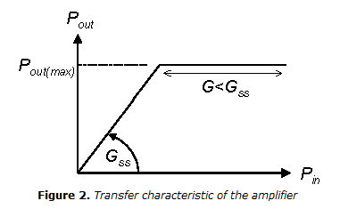

Figure 10.Transfer characteristic of the amplifier

Note: The default value of the OutputPowerMax parameter is set to a high value to neglect the gain saturation. If this effect should be taken into account, the maximum output power should be properly set.

An arbitrary user-specified gain profile can be defined by providing an ASCII file. The switch GainShapeDescription should be set to GainShapeFile and the file name is defined by the GainShapeFilename parameter.

The file format is described in [Table 1](mk:@MSITStore:C:\\Program%20Files\\VPI\\VPItransmissionMaker%208.7\\doc\\modules.chm::/AmpSysOpt.html" \l "1935065" \o "AmpSysOpt).

# Loop

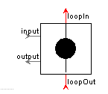

Figure:11

The loop helps us to design loop structures. The loop structure to be built starts at the loopOut port and terminates at the loopIn port of the module. A signal released into the loop via the input port will execute a certain number of times through the ring and end afterwards at the output port.

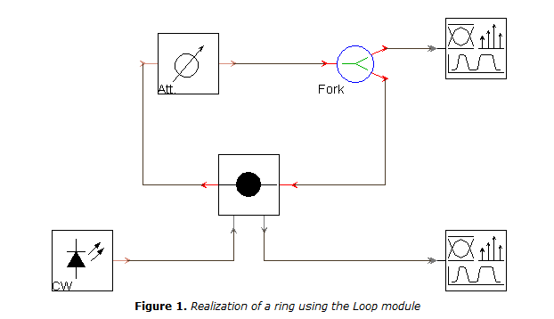

Figure:12 Realization of a ring using the loop module

# Nonlinear Dispersive Fiber (NLS)

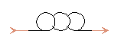

Figure 13:

Nonlinear dispersion-shifted fibers are designed and fabricated for efficient nonlinear effect generation. In order to utilize positively the nonlinear optical phenomena of the optical fiber, it is desirable for the optical fiber to have a desired dispersion value at the wavelength of the input light. Particularly, in order to utilize wavelength conversion, it is desirable for the optical fiber to have a zero dispersion wavelength in the vicinity of the wavelength of the input light. However, when it comes to a nonlinear optical fiber, in which it is difficult to adjust the zero dispersion wavelength, it is difficult to manufacture a plurality of different kinds of optical fiber differing from each other in the zero dispersion wavelength corresponding to the wavelength of the input light for carrying out optical signal processing of, for example, the wavelength multiplex transmission light.

# PowerEqualizerOpt

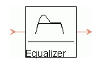

Figure:14

To equalize the optical power, the spectrum of the signal is divided into uniformly-spaced frequency intervals, specified by a Frequency Grid . The power profile of the signal is evaluated on the frequencies of the Frequency Grid and is compared with the user-defined power profile where upon the attenuation profile applied to the input signal is generated.

The module has two basic operating modes, specified by the EqualizationMode parameter. In ‘Goal’ mode, the transmission function of the equalizer is set to obtain the user-specified power per channel at the output. In ‘Threshold’ mode, the profile of the attenuation function is additionally uniformly scaled to reduce loss until it reaches the value of the MinAttenuation parameter. For both modes, the equalizer loss is bounded by the MinAttenuation and MaxAttenuation parameters. The frequencies at which the power is equalized are bounded by the FrequencyMin and FrequencyMax parameters.

# Optical Filter

Amplified spontaneous emission (ASE) noise rejection filter uses an

interference filter that achieves a wideband signal transmission and high

level ASE noise rejection in erbium doped fiber amplifiers. These filters are ideal for pre-amplifier and wavelength division multiplexing (WDM) in-line amplifier applications.

# Direct Receiver

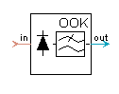

Figure 17:

The front end of the receiver consists of photodetector and preamplifer which in turn is basically a photodiode followed by electrical amplifier and filter modules. The Photodiode module allows us to choose PIN or APD type of photodiode, and electrical amplifier is used in order to describe the conversion of incident optical signal to electrical signal. This above diagram represents an optical direct receiver .The frequency response of the receiver's front end is specified by the transfer function of electrical filter. Also, the back end of receiver is modeled by electrical amplifier and filter, which allows us to specify gain and transfer function of main amplifier and channel filter. The equivalent input noise of the receiver can be added to the ThermalNoise of the photodiode. 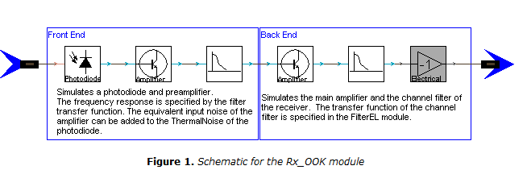

Figure 18

Special features, developed to model Coarse-WDM systems, allow broadband optical noise and signalsin multiple-frequency-bands (MFBs) to be treated efficiently without excessive memory consumption.

# Optical and Electrical Signal Analyzer

# 

Figure 19:

The functionality of several visualizing and analyzing tools likeoptical spectrum analyzer, optical and electrical oscilloscopes, radio-frequency spectrum analyzer, eye diagram analyzer and BER estimator, are integrated in a single analyzer tool.

1. **Simulation Results:**

**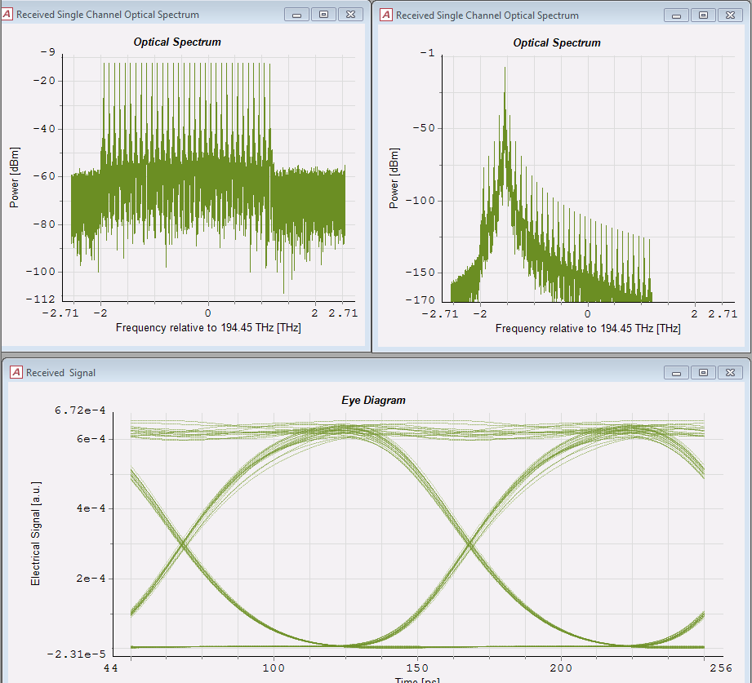**

**Figure 20**

1. **Conclusion:**

The design was implemented in the VPI Transmission maker software with relative success and

the required BER was well maintained below 10^-15. The practical implementation of this design will be tougher to be bound by the set parameters since of the number of loops (repeaters) being used to cover the total distance will add a lot of undesired effects like signal degradation.

**References:**

1. Optical Fiber Communication System by Le Nguyen Binh

2. VPI Transmission Maker & VPI Component maker

3. Fiber-optic communication system by Govind P. Agrawal

4. www.wikipedia.org